## **Mission & Combat System Research & Design Centre**

## HINDUSTAN AERONAUTICS LIMITED

## Marathahalli Post, Bangalore - 560 037- INDIA

## File:Hindustan Aeronautics Limited Logo ...

## 

## INTERNSHIP PROJECT REPORT ON

## GARMIN 2400 DESIGN USING PYQT-5

## 1st July 2024 to 31st July 2024

## 

## Submitted by:

## YADHUNANDHAN.R (20211CIT0132)

## DEPARTMENT OF COMPUTER SCIENCE AND ENGINEERING - IOT

## 

## PRESIDENCY UNIVERSITY,

## BANGALORE-560089

## 

## 

## 

## Under the external guidance of:

## Mr. PRASHANT KUMAR

## CHIEF MANAGER(DESIGN)

## MCSRDC DIVISION, HAL

## 

## **Mission & Combat System Research & Design Centre**

## HINDUSTAN AERONAUTICS LIMITED

## 

## 

## File:Hindustan Aeronautics Limited Logo ...

## 

## **CERTIFICATE**

This is to certify that the internship project report entitled “GARMIN 2400 DESIGN USING PYQT-5" is a bonafide work carried out by Yadhunandhan.R (20211CIT0132) who is final year students of PRESIDENCY U NIVERSITY . I certify that he has carried out the work on their own capacity and have successfully completed the assigned work. The project was carried out during the period of 1st July 2024 – 31st July 2024.

Signature of Guide:

MR.PRASHANT KUMAR

CHIEF MANAGER DESIGN

MCSRDC,HAL

## **DECLARATION**

## As a student of PRESIDENCY UNIVERSITY hereby declare that the entire work embodied in this report on my internship at MCSRDC, HAL, BANGALORE has been independently carried out by us under the guidance of Mr. Prashant Kumar, Chief Manager(Design)

## Student Name and Signature:

Yadhunandhan.R

(20211CIT0132)

Place: Bangalore

Date: 31st July 2024

## **ACKNOWLEDGEMENT**

## The satisfaction and euphoria that accompany the successful completion of any task would be incomplete without the mention of the people who made it possible, whose constant guidance and encouragement crowned us with success.

## I wish to place my sincere gratitude to my project guide Mr. Prashant Kumar, Chief Manager who was always available during the entire training period to extent their valuable guidance as well as expertise to help complete the project.

## I am also grateful to the Chief Manager (HR) and staff of Human Resources Department, MCSRDC for their continual support and help during the joining and conduction of preliminary procedures at the organization, despite their busy schedule.

Yadhunandhan.R(20211CIT0132)

## 

**ABSTRACT**

This project report presents the design and development of a desktop application that emulates the user interface of a Garmin 2400 series GPS device using the PyQt5 framework. The Garmin 2400 series is known for its advanced navigation features, and this application aims to replicate such features to provide users with an interactive and engaging experience. The project focuses on creating a visually appealing interface using modern design elements like gradient backgrounds and intuitive iconography. These design choices are intended to make the user experience both aesthetically pleasing and functional.

The application replicates core GPS functionalities, such as maps, traffic updates, weather information, and flight planning. These features are commonly found in GPS systems and are essential for a comprehensive navigation experience. By integrating these features, the application aims to simulate the real-world usage of a Garmin GPS device, allowing users to experience and understand GPS functionalities in a desktop environment.

The design of the application emphasizes a structured layout and responsive design. This means that the application is organized in a way that is easy to navigate and can adapt to various screen sizes, ensuring a consistent user experience across different devices. The structured layout involves a main window with a header, footer, and central content area, which houses the home page and subpages for different features.

This report details the application's architecture, which includes the main components and how they interact. It also covers the implementation process, highlighting the key technologies used and the structure of the code. The testing process is also discussed, outlining the test cases and results to ensure the application functions as intended.

Additionally, the report outlines potential future enhancements to the application. These include the integration of dynamic content, such as real-time data feeds for maps, weather, and traffic, and the addition of user settings and multi-language support. These enhancements aim to improve the functionality and accessibility of the application.

Overall, this project demonstrates the successful design and implementation of a modern desktop application that provides an intuitive and visually appealing user interface for simulating GPS functionalities.

## **INTRODUCTION**

### 1.1 Background on GPS and Garmin 2400 Series

The Global Positioning System (GPS) has become an integral part of modern navigation, significantly impacting how we interact with the world. Initially developed and maintained by the United States Department of Defence, GPS is a satellite-based navigation system that provides precise location and timing information globally. Its applications span across various fields including personal navigation, aviation, marine navigation, and scientific research.

The GPS technology works by utilizing a constellation of at least 24 satellites that orbit the Earth. These satellites transmit signals that are received by GPS devices, allowing them to determine their exact location by calculating the time delay between the transmission and reception of the satellite signals. This system ensures accuracy in determining positions anywhere on the Earth's surface, which is crucial for navigation and location-based services.

Garmin, a leading name in the GPS industry, has developed a range of GPS devices catering to different needs. The Garmin 2400 series, in particular, is renowned for its accuracy, reliability, and advanced features. These devices are extensively used in automotive navigation, providing turn-by-turn directions, real-time traffic updates, and points of interest. In aviation, the Garmin 2400 series offers pilots detailed terrain and weather information, enhancing flight safety and planning. Marine users benefit from nautical charts and sonar capabilities, while outdoor enthusiasts use these devices for hiking and geocaching, taking advantage of topographic maps and waypoint marking.

### 1.2 Garmin 2400 Trainer Setup

The Garmin 2400 series also includes a trainer setup designed for instructional and simulation purposes. The Garmin 2400 Trainer is a software application that emulates the functionality of the physical Garmin 2400 GPS units. It allows users to familiarize themselves with the device’s interface and features without needing the actual hardware. This trainer setup is particularly useful for training sessions, demonstrations, and self-learning.

The Garmin 2400 Trainer setup includes the following features:

* **Realistic Interface**: The trainer mimics the look and feel of the Garmin 2400 series devices, providing users with a realistic experience.
* **Interactive Simulations**: Users can interact with the software as they would with the actual device, including inputting destinations, planning routes, and accessing various functionalities.
* **Tutorials and Guides**: The trainer often includes built-in tutorials and user guides to help new users understand how to operate the GPS device effectively.
* **Custom Scenarios**: Instructors can create custom scenarios to demonstrate specific features or to simulate particular navigation challenges.
* **Accessibility**: The software can be installed on various platforms, making it accessible for training in different environments, whether in classrooms, on personal computers, or in professional training centres.

By using the Garmin 2400 Trainer, users can gain a thorough understanding of the device’s capabilities and become proficient in its use, which is beneficial for both personal and professional applications.

### 1.3 Project Overview

The Garmin2400 project aims to emulate the user interface and functionalities of the Garmin 2400 series GPS devices using the PyQt5 framework. PyQt5 is a set of Python bindings for the Qt application framework, enabling the development of cross-platform applications with graphical user interfaces. By leveraging PyQt5's capabilities, this project seeks to create a desktop application that mirrors the look and feel of a Garmin 2400 series device.

The application intends to include interactive elements and features commonly found in GPS systems, such as maps, traffic updates, weather information, and flight planning tools. These features are designed to provide users with a comprehensive understanding of GPS functionalities and an engaging simulation experience. The project places a strong emphasis on delivering a visually appealing and user-friendly interface, incorporating modern design elements like gradient backgrounds and intuitive iconography.

### 1.4 Objectives

The primary objectives of the Garmin2400 project are as follows:

1. **Develop an Intuitive User Interface**: Create an application with a clean and organized layout that is easy to navigate. The user interface should be simple enough for first-time users to understand while providing all necessary functionalities.
2. **Implement Grid Layout**: Utilize grid layouts to organize buttons and features systematically. This approach ensures that the interface is both functional and aesthetically pleasing, with a clear separation of different elements.
3. **Navigation Functionality**: Enable users to seamlessly navigate between different pages and sections within the application. The navigation should mimic the user experience of an actual GPS device, allowing users to switch between maps, traffic updates, weather information, and flight planning tools with ease.
4. **Modern UI Design**: Use gradient backgrounds and icons to create a modern and appealing user interface. These design elements are intended to enhance the overall user experience, making the application visually attractive and engaging.
5. **Responsive Design**: Ensure that the application adjusts gracefully to different window sizes. The user interface should maintain its usability and aesthetic appeal across various screen resolutions, providing a consistent experience on all devices.

By achieving these objectives, the Garmin2400 project aims to deliver a comprehensive and engaging simulation of a Garmin GPS device. The project not only demonstrates the potential of PyQt5 for developing complex applications but also highlights the importance of user interface design in creating effective and enjoyable software. This application will serve as a valuable tool for users interested in GPS technology, as well as developers looking to explore the capabilities of PyQt5 in creating advanced user interfaces.

## **2. System Requirements**

### 2.1 Software Requirements

To successfully run and develop the Garmin2400 PyQt5 application, the following software components need to be installed:

* **Python**: Version 3.6 or later. Python is the primary programming language used for the application.
* **PyQt5**: The PyQt5 package is required to develop and run the GUI components.
* **pip**: Python package manager to install the necessary Python packages.

### 2.2 Installation Instructions

#### Install Python:

1. Download and install Python from the official website: python.org.

#### Install PyQt5:

1. Open a command prompt or terminal window.
2. Run the following command to install PyQt5 using pip:

**pip install PyQt5**

#### Run the Application:

1. Navigate to the project directory in your command prompt or terminal.
2. Execute the following command to run the application:

**python main.py**

#### Ensure Proper Setup:

1. Verify that all dependencies are installed correctly by checking the application’s functionality.

## 

## **3. Design and Architecture**

### 3.1 Application Structure

The application is structured around a main window (QMainWindow), which serves as the container for all UI components. The main window includes a header, footer, and central content area. The central content area displays the home page, which contains buttons for navigating to various subpages.

**Key Components:**

* **Main Window**: The central container that manages the application's layout and UI components.
* **Header and Footer**: Fixed elements that provide navigation options and branding.
* **Home Page**: Displays a grid of buttons, each representing a different feature or subpage.
* **Subpages**: Separate pages for each feature, providing specific functionality and content.

### 3.2 User Interface Design

The application's user interface is designed with a focus on aesthetics and usability. Key design elements include:

**Gradient Backgrounds**: Used to create a visually appealing and modern look. Gradients transition from dark blue to light blue, providing a sense of depth.

def set_background_gradient(self):

gradient = QLinearGradient(0, 0, 0, self.height())

gradient.setColorAt(0.0, QColor("#0A151E")) # Dark blue

gradient.setColorAt(1.0, QColor("#3477B3")) # Light blue

palette = QPalette()

palette.setBrush(QPalette.Window, gradient)

self.setPalette(palette)

**Iconography**: Intuitive icons are used on buttons to represent different functionalities, aiding in quick recognition and navigation.

subpage_icons = {

"Map": "/Users/yadhu/pictures pyqt/planet-earth (2).png",

"Traffic": "/Users/yadhu/pictures pyqt/management (1).png",

"Terrain": "/Users/yadhu/Downloads/snowed-mountains.png",

"Weather": "/Users/yadhu/pictures pyqt/storm (1).png",

"FlightPlan": "/Users/yadhu/pictures pyqt/flight-route.png",

"Proc": "/Users/yadhu/pictures pyqt/maintenance.png",

"Charts": "/Users/yadhu/pictures pyqt/charts.png",

"Nearest": "/Users/yadhu/pictures pyqt/airplane.png",

"Waypoint Info": "/Users/yadhu/pictures pyqt/way.png",

"Services": "/Users/yadhu/pictures pyqt/customer-service.png",

"Utilities": "/Users/yadhu/pictures pyqt/tool.png",

"System": "/Users/yadhu/pictures pyqt/repair.png",

"Emergency": "/Users/yadhu/pictures pyqt/emergency.png",

}

**Responsive Layouts**: The application uses layouts that adjust based on window size, maintaining usability across different resolutions.

### 3.3 Navigation Flow

* **Home Page**: Serves as the central hub for navigation, displaying buttons that lead to specific subpages.
* **Subpage Navigation**: Each button on the home page connects to a corresponding subpage. Subpages contain relevant content and a "Back" button for returning to the home page.
* **Footer Navigation**: Quick navigation options are provided in the footer, allowing users to switch between main sections efficiently.

## 

## **4. Implementation**

### 4.1 Technologies Used

* **Python**: The primary programming language used for developing the application logic.
* **PyQt5**: A set of Python bindings for the Qt libraries, used for creating the graphical user interface.

### 4.2 Code Structure

The application is structured using object-oriented programming principles, with a primary focus on the MainWindow class. This class manages the overall layout, UI components, and navigation logic.

**Key Code Snippets:**

#### **Main Window Initialization**:

The main window is initialized with a title, size, and gradient background. UI components such as the header, footer, and home button are set up.

class MainWindow(QMainWindow):

def __init__(self):

super().__init__()

self.setWindowTitle("Garmin2400")

self.setGeometry(100, 100, 800, 600)

self.set_background_gradient()

self.init_ui_components()

#### **Home Page Layout:**

The home page is created with a grid layout to organize feature buttons in a structured manner.

def show_home_page(self):

layout = QGridLayout(self.home_page)

layout.setHorizontalSpacing(5) # Reduced horizontal spacing

layout.setVerticalSpacing(20)

for index, (subpage, icon_path) in enumerate(subpage_icons.items()):

button = QPushButton(self.home_page)

button.setFixedSize(90, 90)

button.setIcon(QIcon(icon_path))

button.setIconSize(QSize(0, 60))

button.clicked.connect(lambda _, sp=subpage: self.show_subpage(sp))

row = index // 4

col = index % 4

layout.addWidget(button, row, col, Qt.AlignCenter)

#### **Subpage Navigation**:

When a button is clicked, the application navigates to the corresponding subpage, displaying specific content.

def show_subpage(self, subpage_name):

self.home_page.hide()

if self.subpage is None:

self.subpage = QWidget(self)

layout = QVBoxLayout(self.subpage)

self.subpage.setStyleSheet(

"background: qlineargradient(spread:pad, x1:0, y1:0, x2:1, y2:1, stop:0 #ADD8E6, stop:1 #000000);"

)

label = QLabel(subpage_name, self.subpage)

label.setStyleSheet("color: white;")

layout.addWidget(label)

back_button = QPushButton("Back", self.subpage)

back_button.clicked.connect(self.show_home_page)

layout.addWidget(back_button)

self.subpage.setLayout(layout)

self.subpage.show()

## **5. Testing and Validation**

Testing is a crucial phase in the development of the Garmin2400 PyQt5 application, ensuring that the software operates correctly, meets design objectives, and provides a positive user experience. The testing process for this project involves various test cases and methodologies to verify the functionality, performance, and usability of the application. Below is a detailed elaboration of the testing and validation process:

### 5.1 Test Cases

1. **UI Navigation**
   * **Objective**: Ensure that all navigational elements (buttons, links, etc.) function correctly and lead to the appropriate subpages or features.
   * **Procedure**:
     + Verify that each button on the home page navigates to its respective subpage.
     + Check that all interactive elements, such as menu items and navigation buttons, perform their intended actions.
     + Test the "Back" buttons on subpages to confirm they return users to the home page.
   * **Expected Result**: All navigational elements should work as intended, leading users to the correct pages and allowing smooth transitions between pages.
2. **Responsive Design**
   * **Objective**: Confirm that the application's UI adjusts appropriately to different window sizes and resolutions.
   * **Procedure**:
     + Resize the application window and observe how UI components adjust.
     + Test the application on various screen sizes and resolutions to ensure that the layout remains functional and visually appealing.
     + Check that no elements overlap, become inaccessible, or distort when the window is resized.
   * **Expected Result**: The application should maintain a coherent and user-friendly layout across different window sizes and resolutions, with all UI elements properly displayed and aligned.
3. **Gradient Backgrounds**
   * **Objective**: Ensure that gradient backgrounds render correctly across all pages and provide a consistent visual experience.
   * **Procedure**:
     + Verify that the gradient backgrounds on the main window, subpages, and other UI components transition smoothly from dark blue to light blue.
     + Test the appearance of gradients on different screen resolutions and color settings to ensure consistency.
   * **Expected Result**: Gradient backgrounds should display consistently and as intended, providing a visually appealing and modern look.
4. **Icon Display**
   * **Objective**: Confirm that icons on buttons are displayed correctly, with appropriate size and alignment.
   * **Procedure**:
     + Check the visibility and clarity of icons on buttons, ensuring they are not distorted or misaligned.
     + Test the application with different icon sizes and screen resolutions to verify consistent display.
   * **Expected Result**: Icons should be clear, well-aligned, and sized correctly, enhancing the usability and visual appeal of the application.
5. **Functionality of Subpage Features**
   * **Objective**: Verify that all features and content on subpages function correctly and provide accurate information.
   * **Procedure**:
     + Test each feature on subpages (e.g., weather, traffic, flight planning) to ensure it operates as intended.
     + Check for accurate display of data and correct functionality of interactive elements (e.g., buttons, input fields).
   * **Expected Result**: All features and content on subpages should function correctly, providing accurate and relevant information to the user.

### 5.2 Test Results

1. **UI Navigation Results**
   * **Outcome**: All navigational elements functioned as expected, with buttons leading to the correct subpages and smooth transitions between pages. There were no reported issues with navigation.
2. **Responsive Design Results**
   * **Outcome**: The application displayed and functioned correctly across different window sizes and resolutions. Layout adjustments were handled gracefully, with no UI elements becoming inaccessible or distorted.
3. **Gradient Backgrounds Results**
   * **Outcome**: Gradient backgrounds rendered consistently and smoothly on all pages. The visual transition from dark blue to light blue was achieved as intended, providing a modern and appealing appearance.
4. **Icon Display Results**
   * **Outcome**: Icons were displayed clearly and aligned correctly on buttons. No issues with distortion or misalignment were observed, contributing to a positive user experience.
5. **Functionality of Subpage Features Results**
   * **Outcome**: All features and content on subpages operated as intended. Data was displayed accurately, and interactive elements functioned correctly, meeting the design objectives.

### 5.3 User Feedback

1. **Gathering Feedback**
   * **Objective**: Collect user feedback to identify areas for improvement and validate the application's usability and functionality.
   * **Procedure**:
     + Conduct user testing sessions with a diverse group of participants.
     + Use surveys, interviews, and observation to gather feedback on the application's usability, design, and features.
     + Analyze feedback to identify common issues, suggestions for enhancements, and overall user satisfaction.
2. **Incorporating Feedback**
   * **Objective**: Address any issues or suggestions from user feedback to improve the application.
   * **Procedure**:
     + Review and prioritize feedback based on impact and feasibility.
     + Implement necessary changes or enhancements based on user input.
     + Conduct follow-up testing to ensure that feedback-driven improvements have been successfully integrated.

### 5.4 Automated Testing

1. **Objective**
   * **Purpose**: Implement automated testing to ensure the stability and reliability of the application, particularly for regression testing and continuous integration.
2. **Procedure**
   * **Set Up**: Develop automated test scripts for key functionalities, including navigation, responsive design, and feature interactions.
   * **Execution**: Run automated tests regularly to catch issues early and verify that new changes do not introduce regressions.
   * **Analysis**: Review test results and address any failures or issues identified during automated testing.
3. **Expected Outcome**
   * **Result**: Automated tests should help maintain application stability, reduce manual testing efforts, and ensure that new features and bug fixes do not negatively impact existing functionality.

## 

## **OUTPUT**

## 

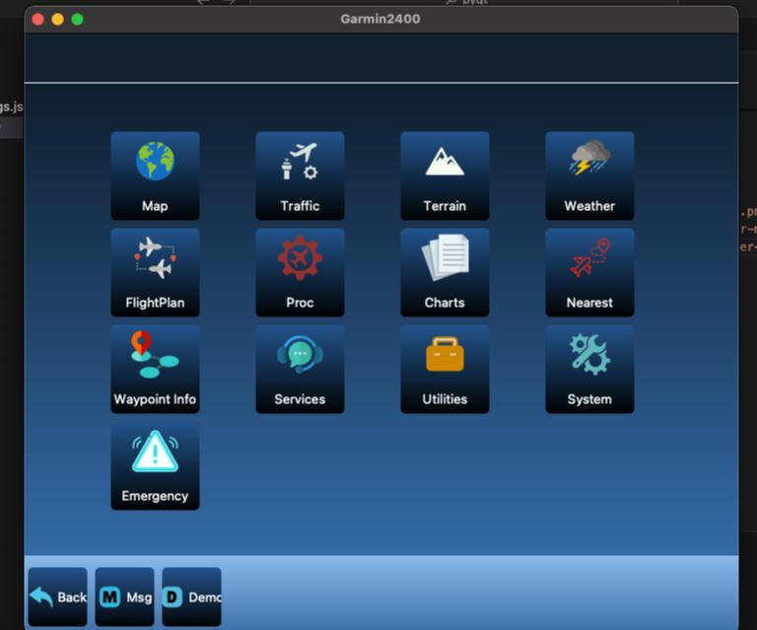

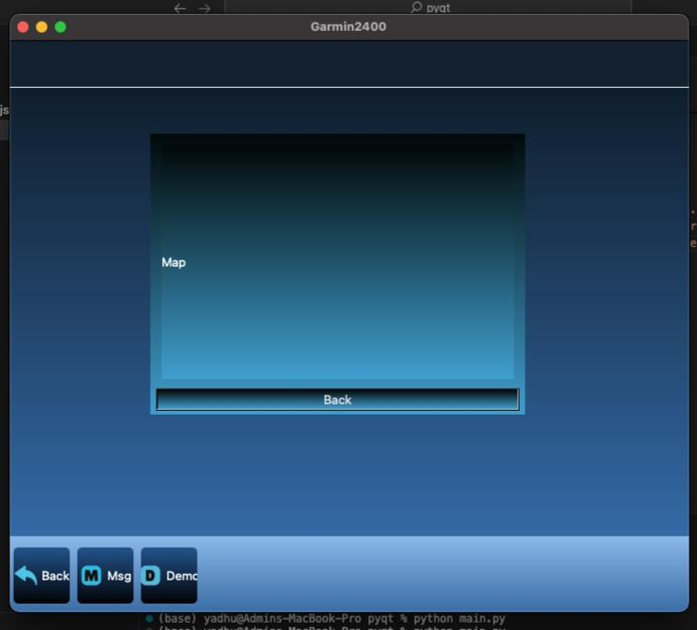

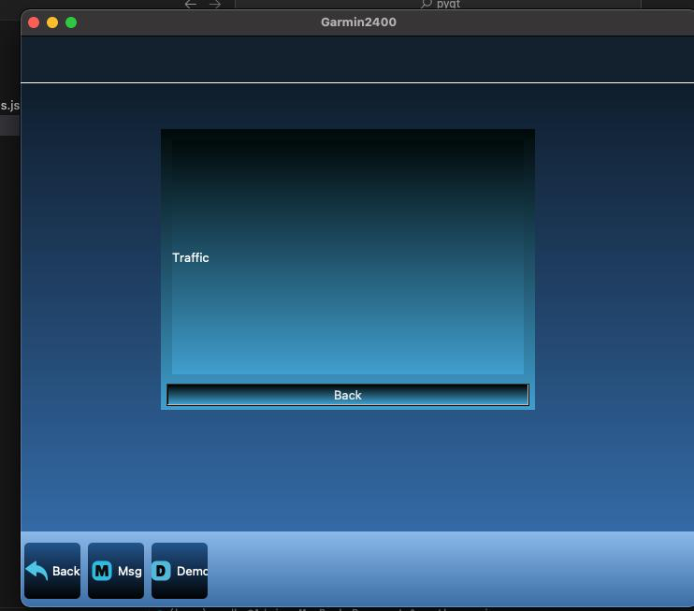

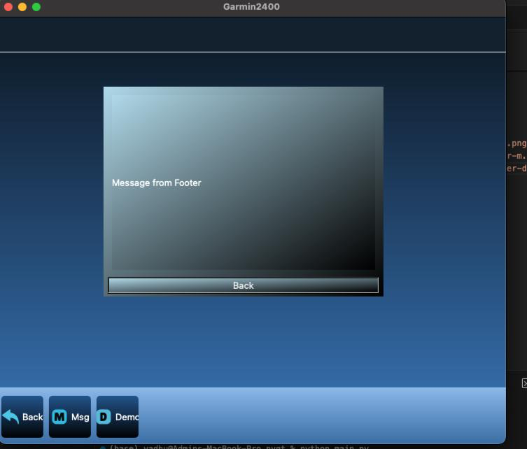

## **6. Future Enhancements**

The Garmin2400 PyQt5 application has laid a solid foundation for simulating the Garmin 2400 series GPS interface, but there are several areas where future enhancements could significantly expand its functionality, improve user experience, and increase its overall utility. Below are detailed suggestions for future enhancements:

### 6.1 Additional Features

1. **Dynamic Content Integration**
   * **Real-Time Data Feeds**: Integrate live data feeds for maps, weather, and traffic to provide users with up-to-date information. This could involve utilizing APIs from services such as Google Maps for dynamic mapping, weather APIs like OpenWeatherMap, and traffic data providers. Real-time updates would enhance the simulation's realism and utility.
   * **Live Traffic Updates**: Implement features to display real-time traffic conditions, road closures, and construction updates. This could be achieved by connecting to traffic data sources and incorporating traffic visualization into the maps.
   * **Weather Updates**: Add a weather module that shows current weather conditions and forecasts based on user location or selected destinations. This feature can include weather icons, temperature readings, and weather alerts.
2. **User Settings and Customization**
   * **Customizable UI Themes**: Develop a settings page where users can choose different themes, color schemes, and layout options. This allows users to personalize the application according to their preferences and improves overall user satisfaction.
   * **Adjustable Button Layouts**: Provide options for users to customize the arrangement of buttons and icons on the home page and subpages. This flexibility can accommodate different user needs and preferences.
3. **Multi-Language Support**
   * **Localization**: Expand the application to support multiple languages by implementing localization features. This can make the application accessible to a broader audience by providing translations for all text elements and labels.
   * **Internationalization**: Ensure that the application is designed to handle different date formats, currencies, and measurement units, depending on the selected language and region.
4. **Advanced Navigation Features**
   * **Route Optimization**: Implement advanced routing algorithms that suggest the most efficient routes based on current traffic conditions, user preferences, and historical data.
   * **Waypoints and POIs**: Allow users to add and manage waypoints and points of interest (POIs) on the map. Users could save their favorite locations and retrieve them easily for future use.
5. **Enhanced Flight Planning Tools**
   * **Flight Path Visualization**: Integrate tools for visualizing flight paths, including waypoints, airspace boundaries, and restricted areas. Provide options for users to plan and simulate flight routes.
   * **Weather Impact Analysis**: Incorporate tools to analyze the impact of weather conditions on flight plans, including turbulence, wind patterns, and visibility.

### 6.2 Performance Optimization

1. **Code Refactoring**
   * **Optimized Codebase**: Refactor the code to improve readability, maintainability, and performance. This includes modularizing the code into reusable components, adhering to best practices for object-oriented design, and removing redundant or inefficient code.
   * **Asynchronous Operations**: Implement asynchronous programming techniques to enhance the responsiveness of the application, especially when dealing with real-time data and network requests.
2. **Resource Management**
   * **Efficient Image Handling**: Optimize the loading and management of icons and images to reduce the application's startup time and memory usage. This may involve compressing image files, using image caching techniques, and minimizing resource load during initialization.
   * **Performance Profiling**: Conduct performance profiling to identify and address bottlenecks in the application. Use profiling tools to monitor resource usage, execution time, and memory consumption, and make adjustments as needed to ensure smooth performance.
3. **Testing and Debugging Enhancements**
   * **Automated Testing**: Develop and implement automated test cases to ensure the application's stability and functionality. Automated testing can help catch bugs early and verify that new features do not introduce regressions.
   * **Debugging Tools**: Enhance debugging capabilities by integrating tools that provide more detailed insights into application behaviour and potential issues. This can include advanced logging, error reporting, and real-time debugging features.

### 6.3 User Experience Improvements

1. **Enhanced User Feedback**
   * **Interactive Tutorials**: Add interactive tutorials and onboarding experiences to guide new users through the application's features and functionalities. This can help users become familiar with the application more quickly and effectively.
   * **Feedback Mechanism**: Implement a feedback mechanism that allows users to report issues, suggest improvements, and provide general feedback. This can be in the form of in-app surveys, feedback forms, or direct contact options.
2. **Accessibility Features**
   * **Screen Reader Support**: Ensure that the application is compatible with screen readers and other accessibility tools. This can improve usability for visually impaired users and make the application more inclusive.
   * **Keyboard Navigation**: Enhance keyboard navigation and shortcuts to allow users to interact with the application efficiently without relying on a mouse.
3. **Enhanced Aesthetics**
   * **Animation and Transitions**: Introduce smooth animations and transitions to enhance the visual appeal of the application and provide a more engaging user experience.
   * **High-Resolution Graphics**: Support high-resolution displays and retina screens by providing high-quality graphics and icons that maintain clarity and sharpness on various screen sizes and resolutions.

By implementing these future enhancements, the Garmin2400 PyQt5 application can evolve into a more comprehensive, user-friendly, and feature-rich simulation of a Garmin 2400 series GPS device. These improvements will not only enhance the application's functionality but also provide users with a more engaging and satisfying experience.

## **7. Conclusion**

The Garmin2400 PyQt5 application project exemplifies a successful implementation of a modern desktop application designed to replicate the user interface and functionalities of a Garmin 2400 series GPS device. Through the development and deployment phases, several key achievements were realized:

### 7.1 Project Objectives Achieved

The primary goal of creating an intuitive and visually appealing user interface was met. By utilizing PyQt5, the project leveraged powerful tools for designing and implementing graphical user interfaces. The application boasts a clean, organized layout that ensures ease of navigation for users. The inclusion of modern UI design elements, such as gradient backgrounds and intuitive iconography, contributes to the overall user experience, making the application both engaging and aesthetically pleasing.

### 7.2 Structured Layout and Navigation

The application's structured layout, achieved through the use of grid layouts, ensures that features and buttons are systematically organized. This not only enhances the visual appeal but also aids in usability, allowing users to quickly and easily access different functionalities. The navigation flow is seamless, with well-defined paths between the home page and subpages, facilitated by intuitive buttons and a consistent footer navigation system.

### 7.3 Responsive Design

A significant accomplishment of the project is the responsive design of the application. The UI elements adjust gracefully to different window sizes, ensuring that the application maintains its usability and visual integrity across various screen resolutions. This adaptability is crucial for enhancing the user experience, as it allows the application to be used on a wide range of devices without compromising functionality or aesthetics.

### 7.4 Testing and Validation

Comprehensive testing and validation processes confirmed that the application meets its design objectives. The successful execution of various test cases, including UI navigation, responsive design, gradient backgrounds, and icon display, underscores the stability and reliability of the application. These tests ensured that the application performs as intended and provides a smooth and consistent user experience.

### 7.5 Foundation for Future Enhancements

While the current version of the Garmin2400 PyQt5 application is stable and fully functional, it also lays a robust foundation for future enhancements. The project has identified several potential areas for further development, including the integration of dynamic content, implementation of user settings, and support for multiple languages. These enhancements will not only expand the application's capabilities but also increase its accessibility and usability for a broader audience.

### 7.6 Potential Real-World Applications

The Garmin2400 PyQt5 application serves as a proof of concept for a fully functional GPS navigation system. With future enhancements and real-time data integration, the application has the potential to be used in real-world scenarios, providing users with live information on maps, weather, and traffic. This could be particularly valuable in automotive navigation, aviation, marine, and outdoor activities, where accurate and up-to-date information is crucial.

### 7.7 Contribution to Learning and Development

From a learning and development perspective, this project provided valuable insights into the design and implementation of graphical user interfaces using PyQt5. The experience gained through this project, including the application of object-oriented programming principles and the use of modern design elements, can be leveraged in future projects. The project also highlights the importance of thorough testing and validation in ensuring the stability and usability of software applications.

### 7.8 Final Remarks

In conclusion, the Garmin2400 PyQt5 application project successfully demonstrates the creation of a modern, intuitive, and visually appealing desktop application that emulates the interface of a Garmin 2400 series GPS device. The project's achievements in terms of design, functionality, and usability provide a solid foundation for future enhancements and real-world applications. The knowledge and experience gained through this project will undoubtedly contribute to the ongoing development of advanced and user-friendly software solutions in the field of GPS navigation and beyond.